

Universal Characteristic Method of Human Profiling (Pythagoras Character Development Theory)

## Archetype compass

Career, Business, Relationship and Family Success.

###### Name :

## THE ARCHETYPE PROCESSOR

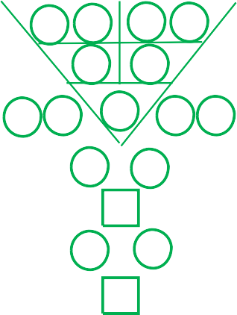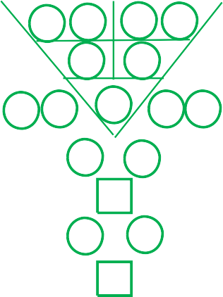

**{q} {first_name} {last_name}**

**Date of Birth** : **{d1} {d2}** - **{mm}** - **{y1} {y2} {y3} {y4}**

**Time of Birth** : **{t1} {t2} : {t3} {t4}**

**Gender** :

**Twins or Triplets** :

**{gender}**

**{twintrip}**

**Report prepared by** : **{user}**

**Date of Prepared : {pd1} – {pm1} – {yy}**

|  |  |  |  |  |
| --- | --- | --- | --- | --- |
|  |  |  |  |  |
| Date of Birth |  |  |  | Time of Birth |

{t3r}

{r3l}

|  |  |  |  |  |  |  |  |  |  |
| --- | --- | --- | --- | --- | --- | --- | --- | --- | --- |
| {d1} | {d2} | {mm} | | | {y1} | | {y2} | {y3} | {y4} |
|  | | | | | | | | | |
|  | {r11} | | {r12} |  | | {r13} | {r14} | |  |
|  |  | | {r21} |  | | {r22} |  | |  |
| {r31} | {r32} | |  | {r33} | |  | {r34} | | {r35} |
| {r41} | | | |  | | {r42} | | | |
|  | | | | {r51} | |  | | | |
| {r61} | | | |  | | {r62} | | | |
|  | | | | {r71} | |  | | | |

{r3r}

{t3l}

|  |  |  |  |  |  |  |  |  |  |
| --- | --- | --- | --- | --- | --- | --- | --- | --- | --- |
| {d1} | {d2} | {mm} | | | {t1} {t2} | | | {t3} | {t4} |
|  | | | | | | | | | |
|  | {t11} | | {t12} |  | | {t13} | {t14} | |  |
|  |  | | {t21} |  | | {t22} |  | |  |
| {t31} | {t32} | |  | {t33} | |  | {t34} | | {t35} |
| {t41} | | | |  | | {t42} | | | |
|  | | | | {t51} | |  | | | |
| {t61} | | | |  | | {t62} | | | |
|  | | | | {t71} | |  | | | |

Destiny Number

|  |
| --- |
| **{r11} {r12} {r13} {r14}** |
| **{r33}** |
| **{r22}** |
| **{r21}** |
| **{r34} {r35}** |
| **{r31} {r32}** |
| **{hpi}** |
| **{hpb}** |
| **{ht1} {ht2} {ht3} {ht4} {ht5}** |
| **{lc1} {lc2} {lc3} {lc4}** |

Universal Character Archetype Personality Strength Number Personality Weakness Number Whole Life Inborn Strength Number

Whole Life Inborn Challenge Number Hidden Potential Number - Intuition Hidden Potential Number - Blind Spot Your Hidden Talents Number

Your Life Code

|  |  |  |  |  |  |  |  |  |  |  |  |  |  |  |  |  |  |
| --- | --- | --- | --- | --- | --- | --- | --- | --- | --- | --- | --- | --- | --- | --- | --- | --- | --- |
|  | **49 Steps To Know Your True Self** | | | | | | | | | | | | | | | |  |
|  | | | | | | | | | | | | | | | |
|  | 1 | **{r33}** | 8 | **{r14} {r22}** | 15 | **{r33} {r42}** | 22 | **{r12} {r21}** | 29 | **{r33} {r34}** | 36 | **{s} {r13}** | 43 | **{r14} {r33}** |  |
| 2 | **{r11} {r12}** | 9 | **{r22}** | 16 | **{r13} {r22}** | 23 | **{r21} {r32}** | 30 | **{r14} {r21}** | 37 | **{r11} {r33}** | 44 | **{r51} {r61}** |
| 3 | **{r13} {r14}** | 10 | **{r22} {r33}** | 17 | **{r22} {r34}** | 24 | **{r21} {r31}** | 31 | **{r22} {r31}** | 38 | **{r11} {r22}** | 45 | **{r51} {r62}** |
| 4 | **{r21} {r22}** | 11 | **{r33} {r41}** | 18 | **{r22} {r35} {r13}** | 25 | **{r32} {r41}** | 32 | **{r35} {r41}** | 39 | **{r12} {r22}** | 46 | **{r61} {r71}** |
| 5 | **{r31} {r32}** | 12 | **{r11} {r21}** | 19 | **{r34} {r42}** | 26 | **{r31} {r41}** | 33 | **{r11} {r13}** | 40 | **{r12} {r33}** | 47 | **{r62} {r71}** |
| 6 | **{r34} {r35}** | 13 | **{r21}** | 20 | **{r35} {r42}** | 27 | **{r41} {r51}** | 34 | **{r11} {r14}** | 41 | **{r13} {r21}** | 48 | **{r33} {r51}** |
| 7 | **{r41} {r42}** | 14 | **{r21} {r33}** | 21 | **{r42} {r51}** | 28 | **{r32} {r33}** | 35 | **{r12} {s}** | 42 | **{r13} {r33}** | 49 | **{r51} {r71}** |
|  | | | | | | | | | | | | | | | |

**About {first_name} {last_name}**



**Dear {first_name} {last_name}**

{r33}

To understand yourself is the beginning of wisdom.

###### You are {ucInfo1}

{ucInfo2}

**Your physical environment, describe you are: {rval} & {qval}**

{ucInfo3}

###### To describe you the best, you are : {describe}

{ucInfo4}

###### Your Hidden Potential - "Blind Spot" :

###### {hiddenPotentialBlindSpot}

###### Your Hidden Potential - "Intuition" :

{hiddenPotentialIntuition}



|  |  |  |  |
| --- | --- | --- | --- |
| **Interpretation of missing or excessive code for {first_name} {last_name}** | | | |
| **Number** | **Description** | **Quantity** | **Status** |
| 1 | Leadership quality, independent, influential, charismatic, innovative, interpersonal skills. | **{icr1} ( {icq1} )** | **{ics1}** |
| 2 | Diplomacy in communication and good in negotiation. | **{icr2} ( {icq2} )** | **{ics2}** |
| 3 | Fast & aggressive, task-oriented, good Listener, operational. | **{icr3} ( {icq3} )** | **{ics3}** |
| 4 | Strategising, administration work, conscientious, compliance. | **{icr4} ( {icq4} )** | **{ics4}** |
| 5 | Good sense of direction, constructive, building ideas and concepts, principled, grounded. | **{icr5} ( {icq5} )** | **{ics5}** |
| 6 | Family-oriented, protector, charismatic, influential, interpersonal skills. | **{icr6} ( {icq6} )** | **{ics6}** |
| 7 | Lucky, enterprising, dominance, troubleshooter, multi-tasking, problem solving, good in negotiation. | **{icr7} ( {icq7} )** | **{ics7}** |
| 8 | Survivor, responsible, judgemental, disciplined, workaholic. | **{icr8} ( {icq8} )** | **{ics8}** |
| 9 | Creative, good foresight, forward looking, creative, business minded, good in packaging. | **{icr9} ( {icq9} )** | **{ics9}** |
|  | | | |



**Shapes**

**Colours**



**to find the supporting & controlling role for {first_name} {last_name} (intergrating with PCDT, nlp, disc-o and eq)**

**Choices**

**UCA**

### Number

5

**Senses**

Smell (Nose)

**NLP**

### DISC-O EQ

Yellow, Brown, Beige

Self Awareness

(S)

Steady Steadfast

Olfactory

**1st Choice**

You Can Control

See (Eye)

Talk (Mouth)

#### 2 & 7

Social Awareness

Self Management

Relationship Management

Self Motivation

(C) Conscientious Compliance

(I)

Influential Interpersonal

(S)

Social Operational

(D) Dominant

Auditory

Visual

Gustatory

Green

Black, Dark Blue

### 2nd Choice

Support You

### 3rd Choice

Neutral

### 4th Choice

You Support

### 5th Choice

Control You

4 & 9

Red, Orange, Purple, Pink

Listen (Ear)

#### 3 & 8

Kinaesthetic

Gold, Silver, White

Touch (Hand)

1 & 6

**Suggestion of life code card design**

# {lc1} {lc2} {lc3} {lc4} {lc1} {lc2} {lc3} {lc4}

**{lc1} {lc2} {lc3} {lc4}**



|  |  |
| --- | --- |
| **The supporting & controlling career choice For {first_name} {last_name}** | |
| 2 & 7  **1st Choice**  You Can Control | {pc1} |
| 3 & 8  **2nd Choice**  Support You | {pc2} |
| 5  **3rd Choice**  Your Own Number | {pc3} |
| 1 & 6  **4th Choice**  You Support | {pc4} |
| 4 & 9  **5th Choice**  Control You | {pc5} |
|  | |

Potential Heart Bypass : {pothb}

Potential Heart Attack : {potha}

|  |  |  |  |  |
| --- | --- | --- | --- | --- |
| **Personal health check for {first_name} {last_name}** | | | | |
| **Main Body Parts** | | **Quantity** | **Status** | |
| **Lungs** | Lung/large intestine problems, Asthma, Skin allergies problems, Hay fever. | **{hpr1} ( {hpq1} )** | **{hps1}** | |
| **Kidney** | Kidney/bladder problems, Fear/phobias, Low back pain, Sciatica, Frequent urination, Dark shadow/bags under the eyes, Disorders of the central nervous system, Aversion to cold, Impotence/frigidity | **{hpr2} ( {hpq2} )** | **{hps2}** | |
| **Heart** | Heart/small intestine problems, Cardiovascular diseases, Insomnia, Restlessness, Forgetfulness, Speech disorders, Depressed, Pain in chest region, Hypersensitive. | **{hpr3} ( {hpq3} )** | **{hps3}** | |
| **Liver** | Liver/Gallbladder problems, Anger/complete absence, Impatient/easily frustrated, Eye problems, Problems with equilibrium/coordination, Muscle cramps, Lack of flexibility/stiffness, Bitter taste in mouth, Irregular menses, Tendon problems. | **{hpr4} ( {hpq4} )** | **{hps4}** | |
| **Stomach** | Stomach/pancreas/spleen problems, Immune system problem, Digestive problems, Belching, Lack of absorption, Loose Bowels, Anaemia, Haemorrhoids, Overweight or under weight, Inability to receive nutrient, Lymphatic problems. | **{hpr5} ( {hpq5} )** | **{hps5}** | |
|  | | | | {pothd} |
| {potp} |
|  |

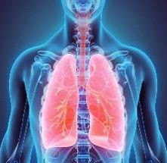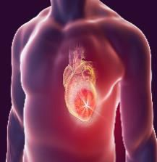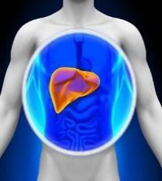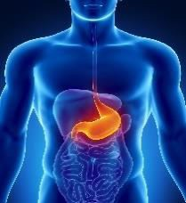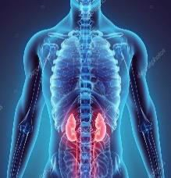

Potential Cancer : {potc}

#### Potential Hereditary Diseases :

Potential Cervical/Prostate Issue :

**9 years world outlook for {first_name} {last_name}**

**Year**

**Year**

**Year**

{w33l}

{w3l}

{w3r}

{w23l}

{w23r}

{w33r}

|  |  |  |  |  |  |  |  |  |  |
| --- | --- | --- | --- | --- | --- | --- | --- | --- | --- |
|  | |  | | | {wy11} | | {wy12} | {wy13} | {wy14} |
| {d1} | {d2} | {mm} | | |  | | |  | |
|  | {w11} | | {w12} |  | | {w13} | {w14} | |  |
|  |  | | {w21} |  | | {w22} |  | |  |
| {w31} | {w32} | |  | {w33**}** | |  | {w34} | | {w35} |
| {w41} | | | |  | | {w42} | | | |
|  | | | | {w51} | |  | | | |
| {w61} | | | |  | | {w62} | | | |
|  | | | | {w71} | |  | | | |
|  | | | | | | | | | |

|  |  |  |  |  |  |  |  |  |  |
| --- | --- | --- | --- | --- | --- | --- | --- | --- | --- |
|  | |  | | | {wy21} | | {wy22} | {wy23} | {wy24} |
| {d1} | {d2} | {mm} | | |  | | |  | |
|  | {w211} | | {w212} |  | | {w213} | {w214} | |  |
|  |  | | {w221} |  | | {w222} |  | |  |
| {w231} | {w232} | |  | {w233} | |  | {w234} | | {w235} |
| {w241} | | | |  | | {w242} | | | |
|  | | | | {w251} | |  | | | |
| {w261} | | | |  | | {w262} | | | |
|  | | | | {w271} | |  | | | |
|  | | | | | | | | | |

|  |  |  |  |  |  |  |  |  |  |
| --- | --- | --- | --- | --- | --- | --- | --- | --- | --- |
|  | |  | | | {wy31} {wy32} | | | {wy33} | {wy34} |
| {d1} | {d2} | {mm} | | |  | | |  | |
|  | {w311} | | {w312} |  | | {w313} | {w314} | |  |
|  |  | | {w321} |  | | {w322} |  | |  |
| {w331} | {w332} | |  | {w333} | |  | {w334} | | {w335} |
|  |  | | {w341} |  | | {w342} |  | |  |
|  |  | |  | {w351} | |  |  | |  |
|  |  | | {w361} |  | | {w362} |  | |  |
|  |  | |  | {w371} | |  |  | |  |
|  | | | | | | | | | |

**Year**

**Year**

**Year**

{w63l}

{w43l}

{w43r}

{w53l}

{w53r}

{w63r}

|  |  |  |  |  |  |  |  |  |  |
| --- | --- | --- | --- | --- | --- | --- | --- | --- | --- |
|  | |  | | | {wy41} | | {wy42} | {wy43} | {wy44} |
| {d1} | {d2} | {mm} | | |  | | |  | |
|  | {w411} | | {w412} |  | | {w413} | {w414} | |  |
|  |  | | {w421} |  | | {w422} |  | |  |
| {w431} | {w432} | |  | {w433} | |  | {w434} | | {w435} |
| {w441} | | | |  | | {w442} | | | |
|  | | | | {w451} | |  | | | |
| {w461} | | | |  | | {w462} | | | |
|  | | | | {w471} | |  | | | |
|  | | | | | | | | | |

|  |  |  |  |  |  |  |  |  |  |
| --- | --- | --- | --- | --- | --- | --- | --- | --- | --- |
|  | |  | | | {wy51} | | {wy52} | {wy53} | {wy54} |
| {d1} | {d2} | {mm} | | |  | | |  | |
|  | {w511} | | {w512} |  | | {w513} | {w514} | |  |
|  |  | | {w521} |  | | {w522} |  | |  |
| {w531} | {w532} | |  | {w533} | |  | {w534} | | {w535} |
| {w541} | | | |  | | {w542} | | | |
|  | | | | {w551} | |  | | | |
| {w561} | | | |  | | {w562} | | | |
|  | | | | {w571} | |  | | | |
|  | | | | | | | | | |

|  |  |  |  |  |  |  |  |  |  |
| --- | --- | --- | --- | --- | --- | --- | --- | --- | --- |
|  | |  | | | {wy61} {wy62} | | | {wy63} | {wy64} |
| {d1} | {d2} | {mm} | | |  | | |  | |
|  | {w611} | | {w612} |  | | {w613} | {w614} | |  |
|  |  | | {w621} |  | | {w622} |  | |  |
| {w631} | {w632} | |  | {w633} | |  | {w634} | | {w635} |
|  |  | | {w641} |  | | {w642} |  | |  |
|  |  | |  | {w651} | |  |  | |  |
|  |  | | {w661} |  | | {w662} |  | |  |
|  |  | |  | {w671} | |  |  | |  |
|  | | | | | | | | | |

**Year**

**Year**

**Year**

**{wy91} {wy92} {wy93} {wy94}**

**{wy81} {wy82} {wy83} {wy84}**

**{wy71} {wy72} {wy73} {wy74}**

**{wy61} {wy62} {wy63} {wy64}**

**{wy51} {wy52} {wy53} {wy54}**

**{wy41} {wy42} {wy43} {wy44}**

**{wy31} {wy32} {wy33} {wy34}**

**{wy21} {wy22} {wy23} {wy24}**

**{wy11} {wy12} {wy13} {wy14}**

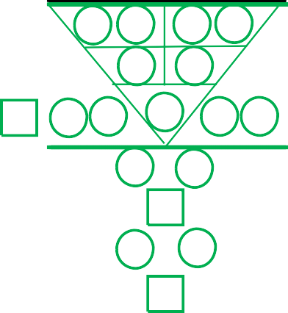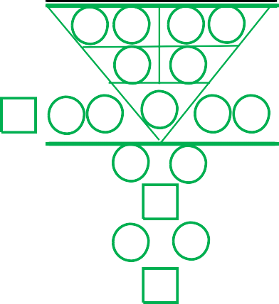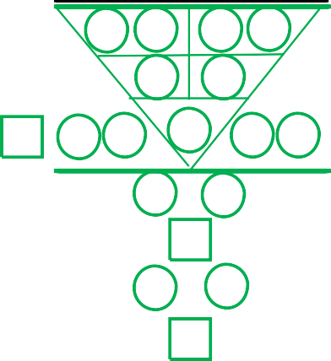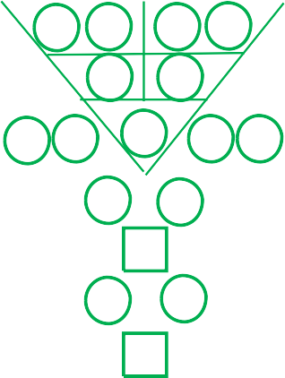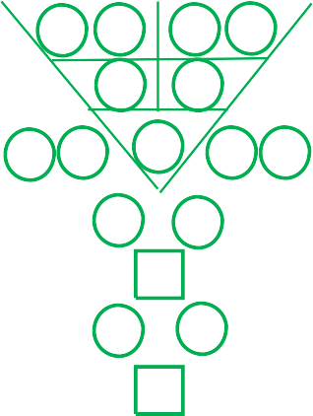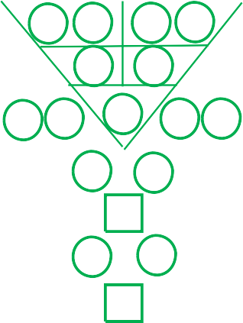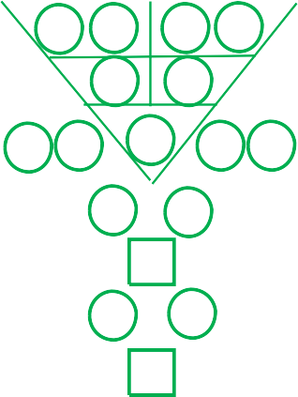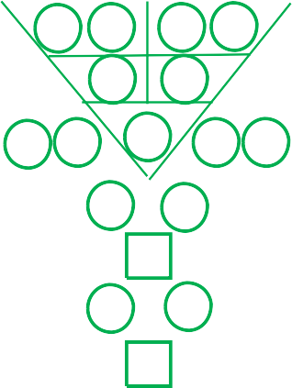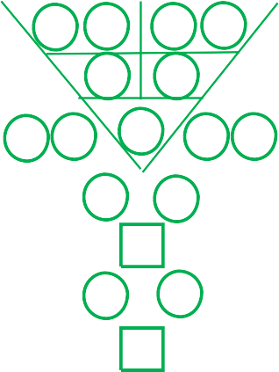

{w93l}

{w73l}

{w73r}

{w83l}

{w83r}

{w93r}

|  |  |  |  |  |  |  |  |  |  |
| --- | --- | --- | --- | --- | --- | --- | --- | --- | --- |
|  | |  | | | {wy71} | | {wy72} | {wy73} | {wy74} |
| {d1} | {d2} | {mm} | | |  | | |  | |
|  | {w711} | | {w712} |  | | {w713} | {w714} | |  |
|  |  | | {w721} |  | | {w722} |  | |  |
| {w731} | {w732} | |  | {w733} | |  | {w734} | | {w735} |
| {w741} | | | |  | | {w742} | | | |
|  | | | | {w751} | |  | | | |
| {w761} | | | |  | | {w762} | | | |
|  | | | | {w771} | |  | | | |
|  | | | | | | | | | |

|  |  |  |  |  |  |  |  |  |  |
| --- | --- | --- | --- | --- | --- | --- | --- | --- | --- |
|  | |  | | | {wy81} | | {wy82} | {wy83} | {wy84} |
| {d1} | {d2} | {mm} | | |  | | |  | |
|  | {w811} | | {w812} |  | | {w813} | {w814} | |  |
|  |  | | {w821} |  | | {w822} |  | |  |
| {w831} | {w832} | |  | {w833} | |  | {w834} | | {w835} |
| {w841} | | | |  | | {w842} | | | |
|  | | | | {w851} | |  | | | |
| {w861} | | | |  | | {w862} | | | |
|  | | | | {w871} | |  | | | |
|  | | | | | | | | | |

|  |  |  |  |  |  |  |  |  |  |
| --- | --- | --- | --- | --- | --- | --- | --- | --- | --- |
|  | |  | | | {wy91} {wy92} | | | {wy93} | {wy94} |
| {d1} | {d2} | {mm} | | |  | | |  | |
|  | {w911} | | {w912} |  | | {w913} | {w914} | |  |
|  |  | | {w921} |  | | {w922} |  | |  |
| {w931} | {w932} | |  | {w933} | |  | {w934} | | {w935} |
|  |  | | {w941} |  | | {w942} |  | |  |
|  |  | |  | {w951} | |  |  | |  |
|  |  | | {w961} |  | | {w962} |  | |  |
|  |  | |  | {w971} | |  |  | |  |
|  | | | | | | | | | |

**2022 monthly world's outlook for {first_name} {last_name}**

**Year Year Year**

**{my11} {my12} {my13} {my14}**

**{my11} {my12} {my13} {my14}**

**{my11} {my12} {my13} {my14}**

**{my11} {my12} {my13} {my14}**

**{my11} {my12} {my13} {my14}**

**{my11} {my12} {my13} {my14}**

**{my11} {my12} {my13} {my14}**

**{my11} {my12} {my13} {my14}**

**{my11} {my12} {my13} {my14}**

|  |  |  |  |  |  |  |  |  |  |
| --- | --- | --- | --- | --- | --- | --- | --- | --- | --- |
|  | | 0 1 | | | {my11} | | {my12} | {my13} | {my14} |
| {d1} | {d2} | {mm} | | |  | | |  | |
|  | {m11} | | {m12} |  | | {m13} | {m14} | |  |
|  |  | | {m21} |  | | {m22} |  | |  |
| {m31} | {m32} | |  | {m33} | |  | {m34} | | {m35} |
| {m41} | | | |  | | {m42} | | | |
|  | | | | {m51} | |  | | | |
| {m61} | | | |  | | {m62} | | | |
|  | | | | {m71} | |  | | | |
|  | | | | | | | | | |

|  |  |  |  |  |  |  |  |  |  |
| --- | --- | --- | --- | --- | --- | --- | --- | --- | --- |
|  | | 0 2 | | | {my11} | | {my12} | {my13} | {my14} |
| {d1} | {d2} | {mm} | | |  | | |  | |
|  | {m211} | | {m212} |  | | {m213} | {m214} | |  |
|  |  | | {m221} |  | | {m222} |  | |  |
| {m231} | {m232} | |  | {m233} | |  | {m234} | | {m235} |
| {m241} | | | |  | | {m242} | | | |
|  | | | | {m251} | |  | | | |
| {m261} | | | |  | | {m262} | | | |
|  | | | | {m271} | |  | | | |
|  | | | | | | | | | |

|  |  |  |  |  |  |  |  |  |  |
| --- | --- | --- | --- | --- | --- | --- | --- | --- | --- |
|  | | 0 3 | | | {my11} {my12} | | | {my13} | {my14} |
| {d1} | {d2} | {mm} | | |  | | |  | |
|  | {m311} | | {m312} |  | | {m313} | {m314} | |  |
|  |  | | {m321} |  | | {m322} |  | |  |
| {m331} | {m332} | |  | {m333} | |  | {m334} | | {m335} |
|  |  | | {m341} |  | | {m342} |  | |  |
|  |  | |  | {m351} | |  |  | |  |
|  |  | | {m361} |  | | {m362} |  | |  |
|  |  | |  | {m371} | |  |  | |  |
|  | | | | | | | | | |

{m33l}

{m3l}

{m3r}

{m23l}

{m23r}

{m33r}

**Year**

|  |  |  |  |  |  |  |  |  |  |
| --- | --- | --- | --- | --- | --- | --- | --- | --- | --- |
|  | | 0 4 | | | {my11} | | {my12} | {my13} | {my14} |
| {d1} | {d2} | {mm} | | |  | | |  | |
|  | {m411} | | {m412} |  | | {m413} | {m414} | |  |
|  |  | | {m421} |  | | {m422} |  | |  |
| {m431} | {m432} | |  | {m433} | |  | {m434} | | {m435} |
| {m441} | | | |  | | {m442} | | | |
|  | | | | {m451} | |  | | | |
| {m461} | | | |  | | {m462} | | | |
|  | | | | {m471} | |  | | | |
|  | | | | | | | | | |

**Year**

**Year**

|  |  |  |  |  |  |  |  |  |  |
| --- | --- | --- | --- | --- | --- | --- | --- | --- | --- |
|  | | 0 6 | | | {my11} {my12} | | | {my13} | {my14} |
| {d1} | {d2} | {mm} | | |  | | |  | |
|  | {m611} | | {m612} |  | | {m613} | {m614} | |  |
|  |  | | {m621} |  | | {m622} |  | |  |
| {m631} | {m632} | |  | {m633} | |  | {m634} | | {m635} |
|  |  | | {m641} |  | | {m642} |  | |  |
|  |  | |  | {m651} | |  |  | |  |
|  |  | | {m661} |  | | {m662} |  | |  |
|  |  | |  | {m671} | |  |  | |  |
|  | | | | | | | | | |

{m63l}

{m43l}

{m43r}

{m53l}

{m53r}

{m63r}

**Year**

|  |  |  |  |  |  |  |  |  |  |
| --- | --- | --- | --- | --- | --- | --- | --- | --- | --- |
|  | | 0 5 | | | {my11} | | {my12} | {my13} | {my14} |
| {d1} | {d2} | {mm} | | |  | | |  | |
|  | {m511} | | {m512} |  | | {m513} | {m514} | |  |
|  |  | | {m521} |  | | {m522} |  | |  |
| {m531} | {m532} | |  | {m533} | |  | {m534} | | {m535} |
| {m541} | | | |  | | {m542} | | | |
|  | | | | {m551} | |  | | | |
| {m561} | | | |  | | {m562} | | | |
|  | | | | {m571} | |  | | | |
|  | | | | | | | | | |

|  |  |  |  |  |  |  |  |  |  |
| --- | --- | --- | --- | --- | --- | --- | --- | --- | --- |
|  | | 0 7 | | | {my11} | | {my12} | {my13} | {my14} |
| {d1} | {d2} | {mm} | | |  | | |  | |
|  | {m711} | | {m712} |  | | {m713} | {m714} | |  |
|  |  | | {m721} |  | | {m722} |  | |  |
| {m731} | {m732} | |  | {m733} | |  | {m734} | | {m735} |
| {m741} | | | |  | | {m742} | | | |
|  | | | | {m751} | |  | | | |
| {m761} | | | |  | | {m762} | | | |
|  | | | | {m771} | |  | | | |
|  | | | | | | | | | |

|  |  |  |  |  |  |  |  |  |  |
| --- | --- | --- | --- | --- | --- | --- | --- | --- | --- |
|  | | 0 8 | | | {my11} | | {my12} | {my13} | {my14} |
| {d1} | {d2} | {mm} | | |  | | |  | |
|  | {m811} | | {m812} |  | | {m813} | {m814} | |  |
|  |  | | {m821} |  | | {m822} |  | |  |
| {m831} | {m832} | |  | {m833} | |  | {m834} | | {m835} |
| {m841} | | | |  | | {m842} | | | |
|  | | | | {m851} | |  | | | |
| {m861} | | | |  | | {m862} | | | |
|  | | | | {m871} | |  | | | |
|  | | | | | | | | | |

**Year**

**Year**

|  |  |  |  |  |  |  |  |  |  |
| --- | --- | --- | --- | --- | --- | --- | --- | --- | --- |
|  | | 0 9 | | | {my11} {my12} | | | {my13} | {my14} |
| {d1} | {d2} | {mm} | | |  | | |  | |
|  | {m911} | | {m912} |  | | {m913} | {m914} | |  |
|  |  | | {m921} |  | | {m922} |  | |  |
| {m931} | {m932} | |  | {m933} | |  | {m934} | | {m935} |
|  |  | | {m941} |  | | {m942} |  | |  |
|  |  | |  | {m951} | |  |  | |  |
|  |  | | {m961} |  | | {m962} |  | |  |
|  |  | |  | {m971} | |  |  | |  |
|  | | | | | | | | | |

**Apr**

**May**

**June**

**Sep**

**Aug**

**July**

**Mar & Dec**

**Feb & Nov**

**Jan & Oct**

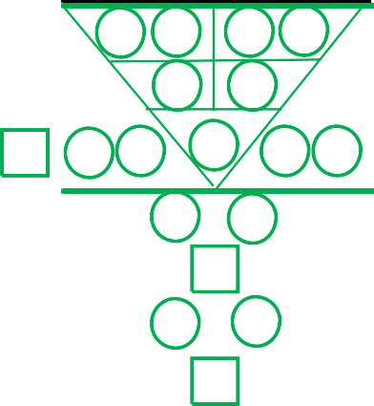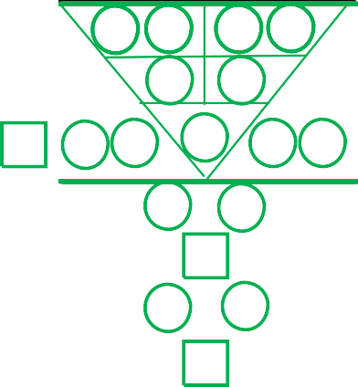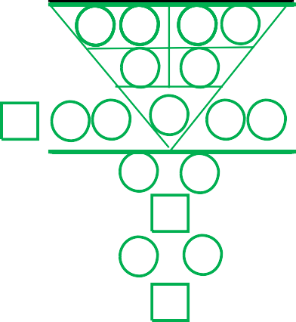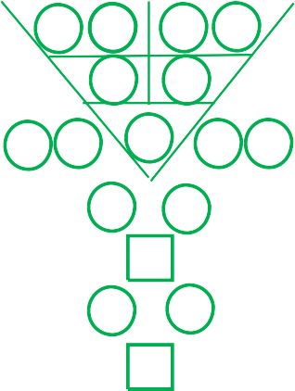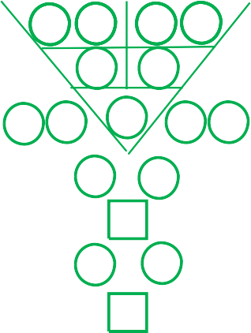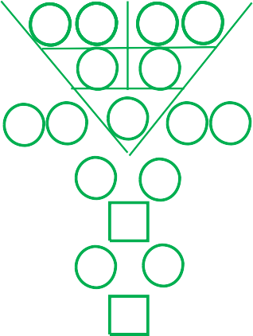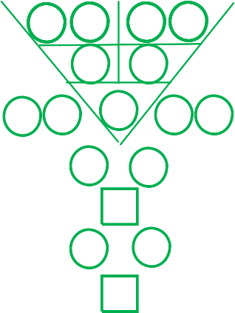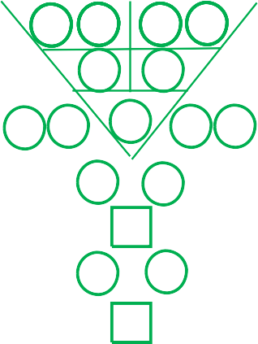

{m93l}

{m73l}

{m73r}

{m83l}

{m83r}

{m93r}

**9 years personal outlook for {first_name} {last_name}**

**Year Year Year**

|  |  |  |  |  |  |  |  |  |  |
| --- | --- | --- | --- | --- | --- | --- | --- | --- | --- |
|  | |  | | | {py11} | | {py12} | {py13} | {py14} |
| {d1} | {d2} | {mm} | | | {y1} {y2} | | | {y3} {y4} | |
|  | {p111} | | {p112} |  | | {p113} | {p114} | |  |
|  |  | | {p121} |  | | {p122} |  | |  |
| {p131} | {p132} | |  | {p133} | |  | {p134} | | {p135} |
| {p141} | | | |  | | {p142} | | | |
|  | | | | {p151} | |  | | | |
| {p161} | | | |  | | {p162} | | | |
|  | | | | {p171} | |  | | | |
|  | | | | | | | | | |

|  |  |  |  |  |  |  |  |  |  |
| --- | --- | --- | --- | --- | --- | --- | --- | --- | --- |
|  | |  | | | {py21} | | {py22} | {py23} | {py24} |
| {d1} | {d2} | {mm} | | | {y1} {y2} | | | {y3} {y4} | |
|  | {p211} | | {p212} |  | | {p213} | {p214} | |  |
|  |  | | {p221} |  | | {p222} |  | |  |
| {p231} | {p232} | |  | {p233} | |  | {p234} | | {p235} |
| {p241} | | | |  | | {p242} | | | |
|  | | | | {p251} | |  | | | |
| {p261} | | | |  | | {p262} | | | |
|  | | | | {p271} | |  | | | |
|  | | | | | | | | | |

|  |  |  |  |  |  |  |  |  |  |
| --- | --- | --- | --- | --- | --- | --- | --- | --- | --- |
|  | |  | | | {py31} {py32} | | | {py33} | {py34} |
| {d1} | {d2} | {mm} | | | {y1} {y2} | | | {y3} {y4} | |
|  | {p311} | | {p312} |  | | {p313} | {p314} | |  |
|  |  | | {p321} |  | | {p322} |  | |  |
| {p331} | {p332} | |  | {p333} | |  | {p334} | | {p335} |
|  |  | | {p341} |  | | {p342} |  | |  |
|  |  | |  | {p351} | |  |  | |  |
|  |  | | {p361} |  | | {p362} |  | |  |
|  |  | |  | {p371} | |  |  | |  |
|  | | | | | | | | | |

{p33l}

{p13l}

{p13r}

{p23l}

{p23r}

{p33r}

**Year**

|  |  |  |  |  |  |  |  |  |  |
| --- | --- | --- | --- | --- | --- | --- | --- | --- | --- |
|  | |  | | | {py41} | | {py42} | {py43} | {py44} |
| {d1} | {d2} | {mm} | | | {y1} {y2} | | | {y3} {y4} | |
|  | {p411} | | {p412} |  | | {p413} | {p414} | |  |
|  |  | | {p421} |  | | {p422} |  | |  |
| {p431} | {p432} | |  | {p433} | |  | {p434} | | {p435} |
| {p441} | | | |  | | {p442} | | | |
|  | | | | {p451} | |  | | | |
| {p461} | | | |  | | {p462} | | | |
|  | | | | {p471} | |  | | | |
|  | | | | | | | | | |

**Year**

|  |  |  |  |  |  |  |  |  |  |
| --- | --- | --- | --- | --- | --- | --- | --- | --- | --- |
|  | |  | | | {py51} | | {py52} | {py53} | {py54} |
| {d1} | {d2} | {mm} | | | {y1} {y2} | | | {y3} {y4} | |
|  | {p511} | | {p512} |  | | {p513} | {p514} | |  |
|  |  | | {p521} |  | | {p522} |  | |  |
| {p531} | {p532} | |  | {p533} | |  | {p534} | | {p535} |
| {p541} | | | |  | | {p542} | | | |
|  | | | | {p551} | |  | | | |
| {p561} | | | |  | | {p562} | | | |
|  | | | | {p571} | |  | | | |
|  | | | | | | | | | |

**Year**

|  |  |  |  |  |  |  |  |  |  |
| --- | --- | --- | --- | --- | --- | --- | --- | --- | --- |
|  | |  | | | {py61} {py62} | | | {py63} | {py64} |
| {d1} | {d2} | {mm} | | | {y1} {y2} | | | {y3} {y4} | |
|  | {p611} | | {p612} |  | | {p613} | {p614} | |  |
|  |  | | {p621} |  | | {p622} |  | |  |
| {p631} | {p632} | |  | {p633} | |  | {p634} | | {p635} |
|  |  | | {p641} |  | | {p642} |  | |  |
|  |  | |  | {p651} | |  |  | |  |
|  |  | | {p661} |  | | {p662} |  | |  |
|  |  | |  | {p671} | |  |  | |  |
|  | | | | | | | | | |

{p63l}

{p43l}

{p43r}

{p53l}

{p53r}

{p63r}

**Year**

|  |  |  |  |  |  |  |  |  |  |
| --- | --- | --- | --- | --- | --- | --- | --- | --- | --- |
|  | |  | | | {py71} | | {py72} | {py73} | {py74} |
| {d1} | {d2} | {mm} | | | {y1} {y2} | | | {y3} {y4} | |
|  | {p711} | | {p712} |  | | {p713} | {p714} | |  |
|  |  | | {p721} |  | | {p722} |  | |  |
| {p731} | {p732} | |  | {p733} | |  | {p734} | | {p735} |
| {p741} | | | |  | | {p742} | | | |
|  | | | | {p751} | |  | | | |
| {p761} | | | |  | | {p762} | | | |
|  | | | | {p771} | |  | | | |
|  | | | | | | | | | |

**Year**

|  |  |  |  |  |  |  |  |  |  |
| --- | --- | --- | --- | --- | --- | --- | --- | --- | --- |
|  | |  | | | {py81} | | {py82} | {py83} | {py84} |
| {d1} | {d2} | {mm} | | | {y1} {y2} | | | {y3} {y4} | |
|  | {p811} | | {p812} |  | | {p813} | {p814} | |  |
|  |  | | {p821} |  | | {p822} |  | |  |
| {p831} | {p832} | |  | {p833} | |  | {p834} | | {p835} |
| {p841} | | | |  | | {p842} | | | |
|  | | | | {p851} | |  | | | |
| {p861} | | | |  | | {p862} | | | |
|  | | | | {p871} | |  | | | |
|  | | | | | | | | | |

**Year**

|  |  |  |  |  |  |  |  |  |  |
| --- | --- | --- | --- | --- | --- | --- | --- | --- | --- |
|  | |  | | | {py91} {py92} | | | {py93} | {py94} |
| {d1} | {d2} | {mm} | | | {y1} {y2} | | | {y3} {y4} | |
|  | {p911} | | {p912} |  | | {p913} | {p914} | |  |
|  |  | | {p921} |  | | {p922} |  | |  |
| {p931} | {p932} | |  | {p933} | |  | {p934} | | {p935} |
|  |  | | {p941} |  | | {p942} |  | |  |
|  |  | |  | {p951} | |  |  | |  |
|  |  | | {p961} |  | | {p962} |  | |  |
|  |  | |  | {p971} | |  |  | |  |
|  | | | | | | | | | |

**{py91} {py92} {py93} {py94}**

**{py81} {py82} {py83} {py84}**

**{py71} {py72} {py73} {py74}**

**{py61} {py62} {py63} {py64}**

**{py51} {py52} {py53} {py54}**

**{py41} {py42} {py43} {py44}**

**{py31} {py32} {py33} {py34}**

**{py21} {py22} {py23} {py24}**

**{py11} {py12} {py13} {py14}**



{p93l}

{p73l}

{p73r}

{p83l}

{p83r}

{p93r}

**THE CLARITY OF D'LIFE JOURNEY**



Clarity of the mind and heart are the keys to empower you to make the right decisions to predict and prevent challenges in all your future life journey.

~ Dr Bernard Yeo, Hon PhD

Dr Bernard Yeo is a researcher and the founder of the Universal Characteristic Method of Human Profiling (UCMHP) and World’s 1st Character Coach. He has spent more than 12 years engaged in deep intensive studies of human behaviour, their personalities and character traits.

He has personally analysed more than 15,000 individuals’birth numbers, stemming across diverse cultures, genders and backgrounds.

In the year 2012, Dr Bernard Yeo received the Asia Pacific Outstanding Business Professional Award for his pioneer work and contributions to the field of applied science character profiling. He was subsequently conferred in 2013 the Honorary Doctor of Philosophy in Human Capital Development and Human Profiling in recognition for his outstanding researched.

Dr Bernard Yeo continues to dig deeper into the mystery’sinsight of the clarity of human psyche and to share his discoveries with the world.

##### UCMHP Academy Pte Ltd

**3 Irving Road, #01-09, Tai Seng Centre Singapore 369522**

**Tel: (65) 6748 6279 Email:** [**cs@ucmhpacademy.com**](mailto:cs@ucmhpacademy.com)

[**www.ucmhpacademy.com**](http://www.ucmhpacademy.com/) **Facebook:** [**www.facebook.com/UCMHP**](http://www.facebook.com/UCMHP)

Copyright © 2012 UCMHP Academy Pte Ltd, All Rights Reserved. Update 2021

**®**